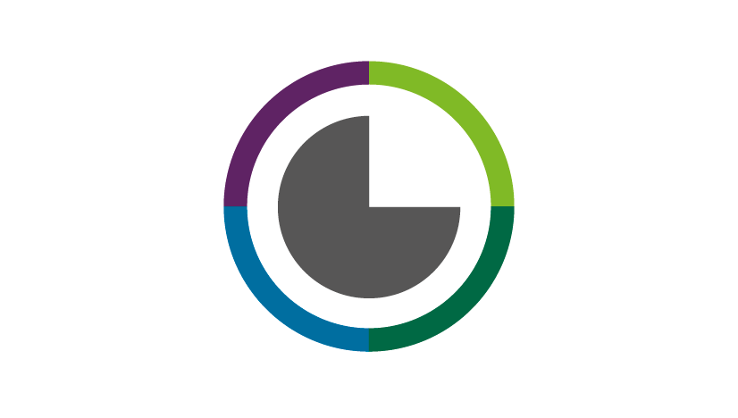

Evidence support request

Healthcare Improvement Scotland’s Evidence Directorate develops evidence-based advice, guidance and intelligence for NHSScotland. We welcome requests for evidence support on issues facing health and social care services. We can assist with broad evidence questions and challenges, or provide a response tailored to a specific issue.

Please submit your request using this form to his.evidence@nhs.scot. We will acknowledge receipt and indicate next steps and timelines. For a full list of our available outputs, please visit our pages on the Healthcare Improvement Scotland website.

If you would like to discuss your request with a member of our team before submitting or if you would like further information about our work, please contact his.evidence@nhs.scot

- Contact & support details

Please provide your name, current role, organisation, email or phone number.
In order to help us gauge the level of interest and need in this topic area, please provide details of groups and networks either involved in, or aware of, your request for support. This may include health and care colleagues, or third and independent sector agencies.

Click or tap here to enter text.

- How can we help you?

Describe the question that needs to be addressed.

You may wish to consider the following:

- What is the anticipated benefit to health, wellbeing or delivery of health and care in Scotland?
- What is the burden of the condition (e.g. mortality, incidence, prevalence)?
- To what extent is there uncertainty (e.g. around the evidence base or best/good practice)?
- Is there inappropriate variation in terms of service provision or outcomes?
- How does this issue affect wider inequalities?
- Are there any areas which should not be covered in this work (i.e. to help define the scope)?

Click or tap here to enter text.

3. Timeframes and outputs

Our outputs vary from brief high level rapid responses to more substantial products that may take several months, depending on the complexity and collaboration required. You can find out more about the work we produce in the appendix to this form or on our website.
Please help us to manage your request for support by providing a timeframe in which you require an output.
Date or timeframe by which output is required?.............
If possible, can you explain the rationale for this date (eg informing a particular meeting): …......

Please tick the output (see appendix for definitions) and timeframe below that best suits your purpose. If you are unsure, leave this blank and we will contact you to discuss your request.

- LITERATURE SEARCH
– rapid response (for urgent time critical questions only) ☐
– standard response ☐

- EVIDENCE SUMMARY
– rapid response (for urgent time critical questions only) ☐
– standard response ☐

- EVIDENCE REVIEW
– rapid response (for urgent time critical questions only) ☐
– standard response ☐

- ECONOMIC ANALYSIS ☐
- HEALTH TECHNOLOGY ASSESSMENT ☐
- CLINICAL GUIDELINE ☐
- STANDARDS OR INDICATORS ☐
- GOOD PRACTICE RECOMMENDATIONS ON ANTIMICROBIAL MEDICATIONS ☐
- OTHER or BESPOKE (please specify in text box below) ☐

Click or tap here to enter text.

4. Current situation and relevance in Scotland

Help us to understand your request by describing the current situation in Scotland.

Please consider the following in your response:
- The relevant population or group
- Relevant epidemiology data or health and care activity data (where appropriate)
- Main health and wellbeing outcomes of interests for both people and service provision
- Current consideration of the topic within health and care (including settings, treatment pathways, national programmes of work, ongoing research, current advice, guidance and standards)
- Relationship to current national priorities/policies, for example of Scottish Government or Healthcare Improvement Scotland.

Click or tap here to enter text.

5. Scope for our work to help inform better health
and social care

We would like to know how our work will be used.
Please help us to understand the likely impact of this work by considering the following:
- What is the rationale for asking us to undertake this work?
- What existing networks, groups or strategies are there that will help with the communication and dissemination of our work and/or implementation of our final output?
- How would successful support be defined, and what measures could be used to evaluate impact?

Click or tap here to enter text.

6. Information to get us started

We welcome any information to help us understand the current situation, including:
- Existing background documentation, references or data sources
- Cost considerations/data (where appropriate)
- Any additional issues related to staffing, training, facilities, infrastructure, etc.
- People with knowledge/expertise in this topic area who could be consulted, including patient organisations/third sector
- Previous or ongoing contact/support from HIS
- Any further information considered relevant.

Click or tap here to enter text.

Please send the completed form to his.evidence@nhs.scot

Please note that the information submitted on this form will be held in accordance with Healthcare Improvement Scotland’s policies. This information may be disclosed to third parties in accordance with the Freedom of Information (Scotland) Act 2002 (FOISA).

Appendix

Evidence Directorate outputs

LITERATURE SEARCH*
A structured search of the published literature is undertaken and list of the references retrieved provided (with abstracts where available).

Evidence summary*
A literature search is undertaken and a brief summary report describing the quantity and type of evidence retrieved and main conclusions provided. This output does not include any appraisal or synthesis of the evidence.

Evidence Review*
A literature search undertaken and a report describing the evidence retrieved and appraising and synthesising this evidence, and drawing conclusions, is provided. This output can vary in length and detail according to the needs of the requestor.

*Rapid responses are based upon brief targeted high level literature search with outputs being available as soon as possible.
Standard responses are based upon more in depth comprehensive literature searches with bibliographies and evidence summaries normally available within 1 to 2 weeks and evidence reviews within 1 to 3 months.

ECONOMIC EVALUATION
An analysis of the costs and benefits offered by a healthcare intervention. Our economic evaluations can include a review of published data, or bespoke analysis for Scotland based on local data.

HEALTH TECHNOLOGY ASSESSMENT (HTA)
A multidisciplinary review designed to determine the value of a health technology within NHSScotland. HTA comprises comprehensive reviews of clinical effectiveness, safety and cost effectiveness, alongside consideration of patient and organisational issues. Our HTAs include a broad range of evidence, including input by patients and experts.

CLINICAL GUIDELINE
A guideline developed using a systematic method to help practitioners and patients make decisions about appropriate health care.

STANDARDS OR INDICATORS
Standards are statements of the level of service the public should expect. They are based on evidence relating to effective clinical and care practice, feasibility and service provision. Indicators support service standards and are tools for quality improvement.

GOOD PRACTICE RECOMMENDATIONS ON ANTIMICROBIAL MEDICATIONS
Provide good practice recommendations for use of antimicrobials and management of infections

